**The Battle of Neighborhoods – New York & Toronto**

**Introduction/Business Problem**

I am going to compare the two major cities which are New York and Toronto. The measurement will be around the most popular venues in the cities. It is very important because both are the most important cities for their countries, the USA and Canada. The two cities contain the most significant events for their country, and also when most people visit these countries, they prefer to visit these cities first. For this reason, this comparison is important for New York and Toronto's tourists and city administration.

**Data** **Section**

I am going to use a dataset that contains boroughs, neighborhoods, and their latitudes and longitudes of New York. Here is the link to the New York dataset: <https://geo.nyu.edu/catalog/nyu_2451_34572>. I will get Toronto boroughs and neighborhoods from Wikipedia by web scraping and use Geospatial data to obtain their latitudes and longitudes. You can see how to obtain data in the following pictures. (Please check the following pages.)

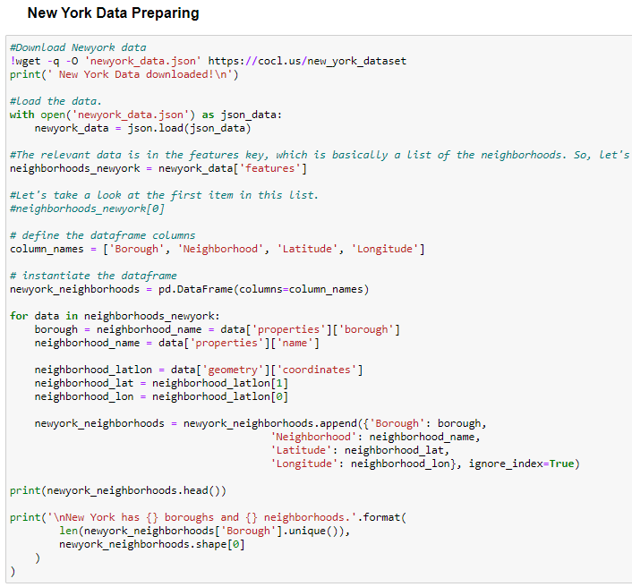

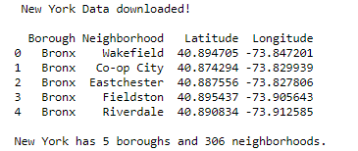

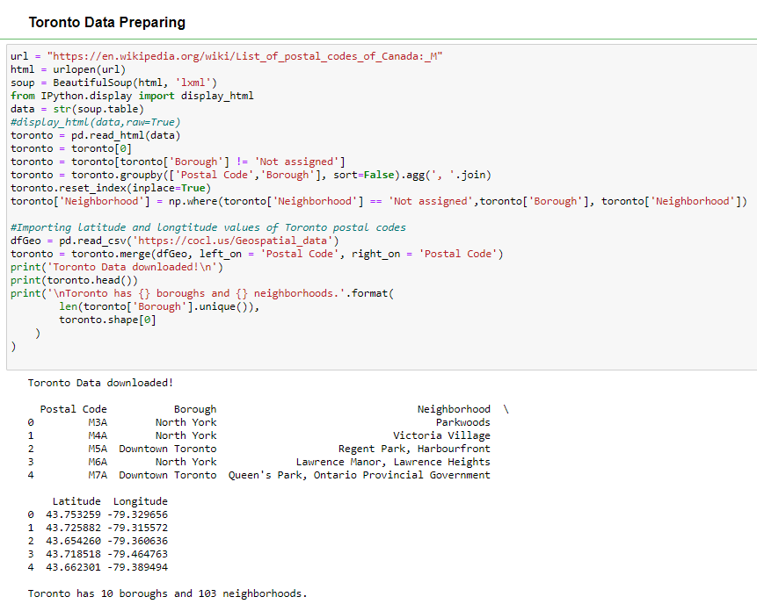

### I used geopy library to get the latitude and longitude values of New York City and Toronto.

### 

### I created folium maps of New York and Toronto with neighborhoods superimposed on top to see closer the cities.

### Newyork:

### 

### Toronto:

### 

And finally, I will use the Foursquare API to get the nearby venues and k-means clustering algorithm to analyze the neighborhoods of New York and Toronto.

New York venue sample;

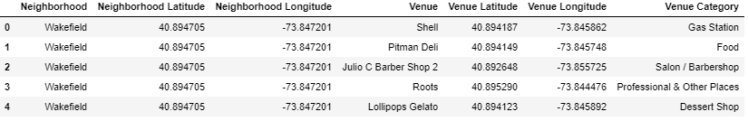

Toronto venue sample;

